Consultant Tracker
EPI-USE

Binary Ninjaz:
Letanyan Arumugam
Sizo Duma
Teboho Mokoena
John Ojo
Kevin Reid
Shaun Yates
Team Photo
Table of Contents
Description 1
Login 1
Admin Mode 1
Consultant Mode 1
Domain Model 2
Technologies 2
Development Methodology 3

Description

Login
The requirements will be fulfilled by a single application. Once a user has logged on, they will be presented with the option to enter admin or consultant mode, with certain options locked out: depending on the privileges of the user—it should be possible to designate a preferred mode, which will be auto selected once logged on.

Admin Mode
The app will provide the user with an overview of projects and resources where project progress can be seen in the form of a progress bar, a project will be highlighted if the hours worked threshold is reached. They should be able to select a project to enter a more detailed, project specific interface, from there; resources can be assigned and monitored; hours assigned; comments seen, and made.

Consultant Mode
Here, the consultant is logged on, and can see an overview of their assigned projects and a progress bar to see what percentage of hours they have logged (and what they still need to log). Any project can be selected to see an overview of comments that have been made, and to make a new comment: this represents an easy way for consultant and manager (admin) to communicate and formally log any issues; from the detailed project view, time can also be logged.

Domain Model

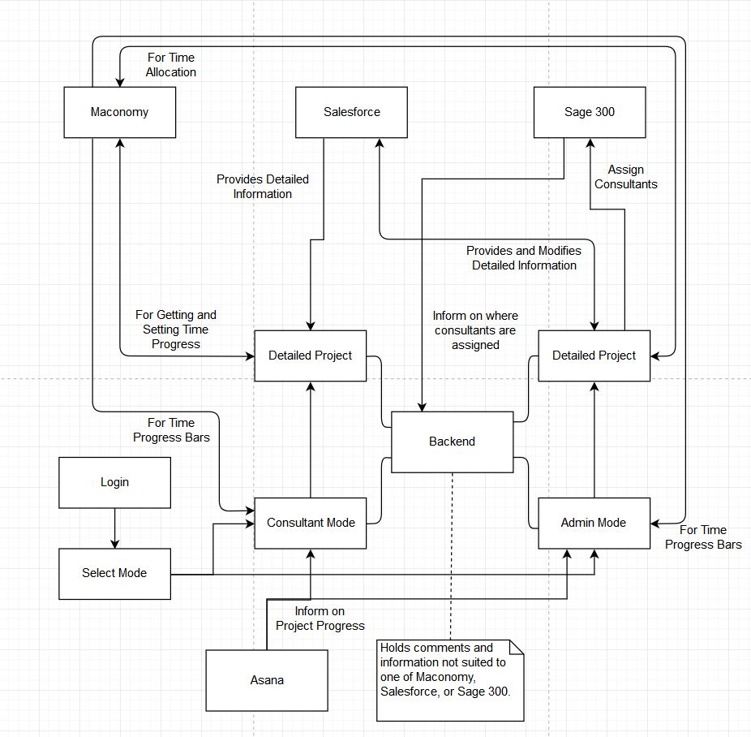
Technologies
As per the specification, we will use:
- OpenUI5 for the frontend,
- Java for the backend,
- MongoDB for the database,
- and potentially REST and SOAP for third party systems.

Development Methodology
The team is very diverse, and ready, capable, and eager to solve a variety of problems. Our meetings as a team should happen regularly, but not unnecessarily, the wonder of the modern world is the ability to so easily communicate, so as far as possible, we will solve what we can without needing to meet every day, so that when a meeting does take place we can keep it concise and informative.
As far as the responsibility of EPI-USE goes: we will need to meet semi-regulary in order to ensure that progress is according to specifications; simultaneously, we will need time to play with Salesforce, Maconomy, Sage 300, and Asana.

